I’ll begin with a little introduction to the scripture passage:
Today we resume what the church’s liturgical calendar calls “Ordinary Time”.
Ordinary…time? It is a slightly underwhelming title…
which defines the portion of the church year that falls outside of
the extra-ordinary seasons of Advent, Christmas, Lent and Easter,
the last of which, perhaps you know,
just concluded this past Sunday with Pentecost.
“Ordinary Time” essentially invites people of faith (us) to recognize the Holy
in the ordinary places and spaces of our lives…
an opportunity to tend to our spiritual growth not so much
by extraordinary events (Christmas’ Holy Birth, Easter’s resurrection,
or Pentecost’s arrival of the Spirit).
Instead, this time in the church year is some “ordinary” time and space
for what Jesuit Walter Burghardt describes
as taking “a long, loving look at the real.”
Paying attention as the Holy shows up in ordinary, everyday places.

Our scripture passage is the first of two creation accounts found in the bible,
today’s being the story of creation across six days.
In the spirit of “a long, loving look at what’s real,”
I will be reading the Creation story,
accompanied by a collection of paintings and photographs,
most notably the artwork of a South African artist whom I just met this week,
Carol Street, who painted Creation’s Six Days,
and who gave us permission to use
her artwork as (she told me) people of faith
around the world have done many times over.
So let’s hear the Word of God,
SEE the Word in painted form,
and experience this mysteriously ordinary story.
Genesis, chapter one: (cue tech assistant for slide progressions)
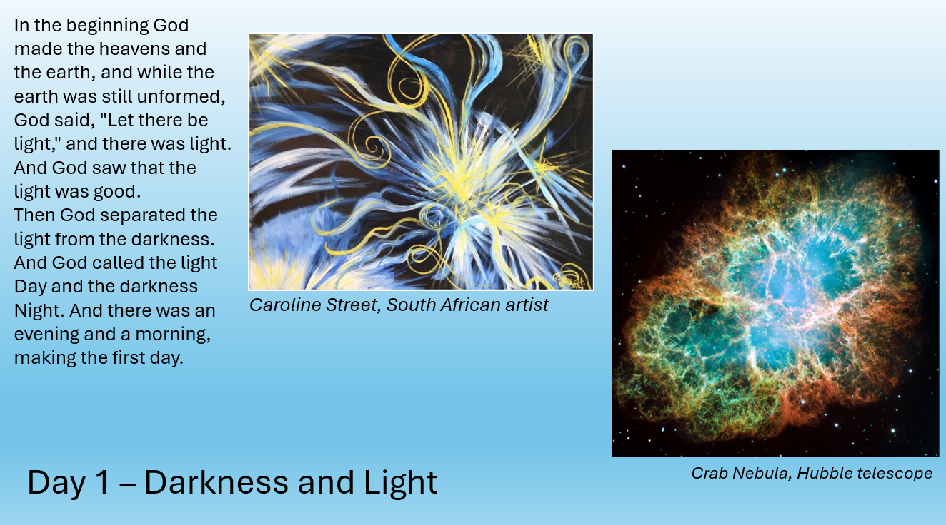
Caroline Street images used with permission
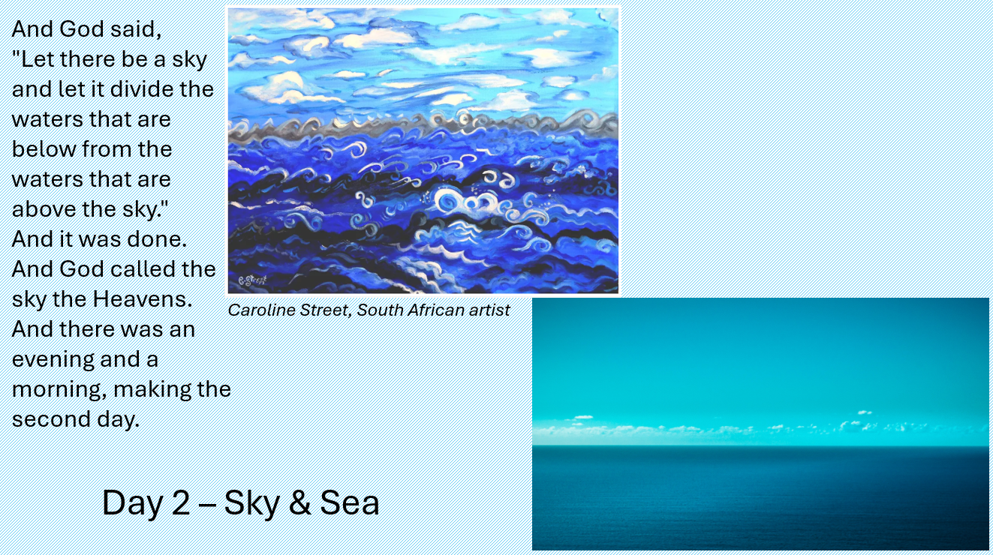

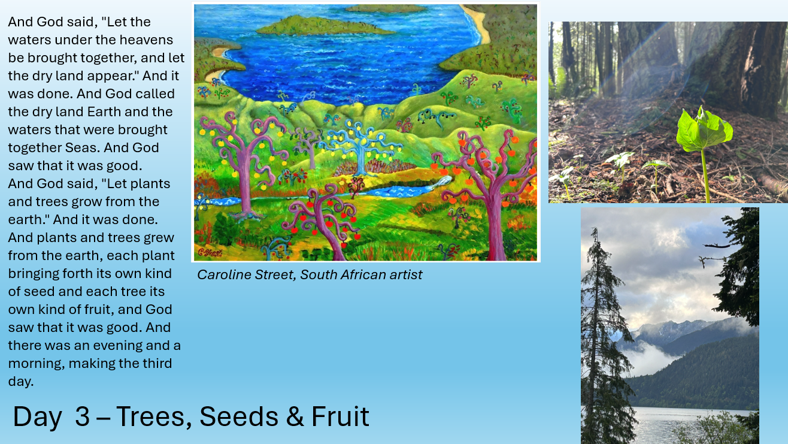

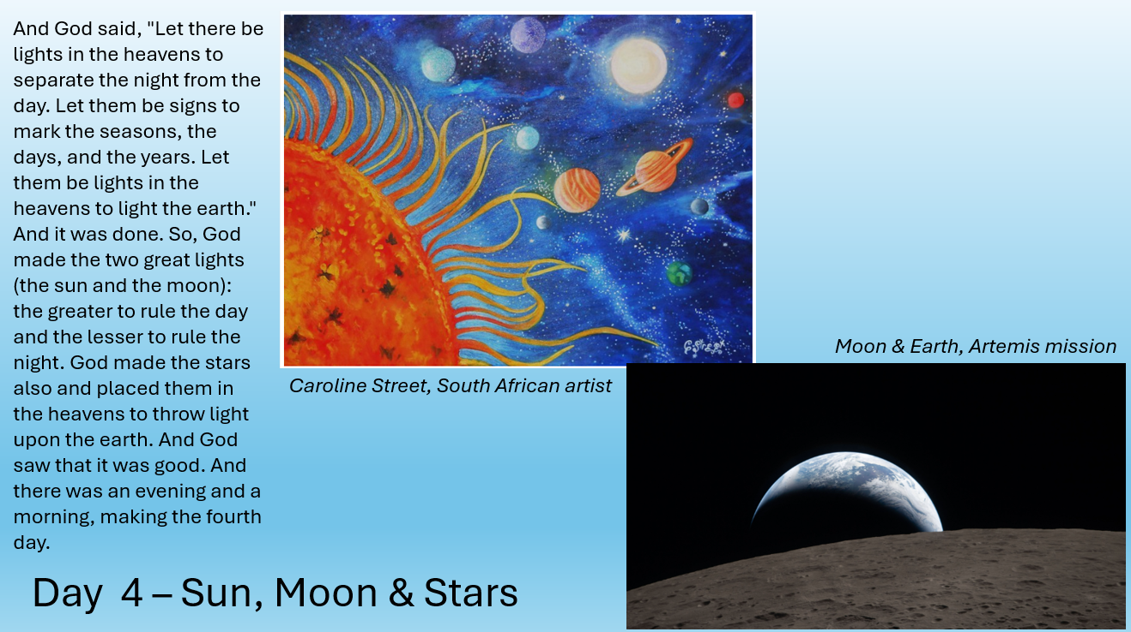

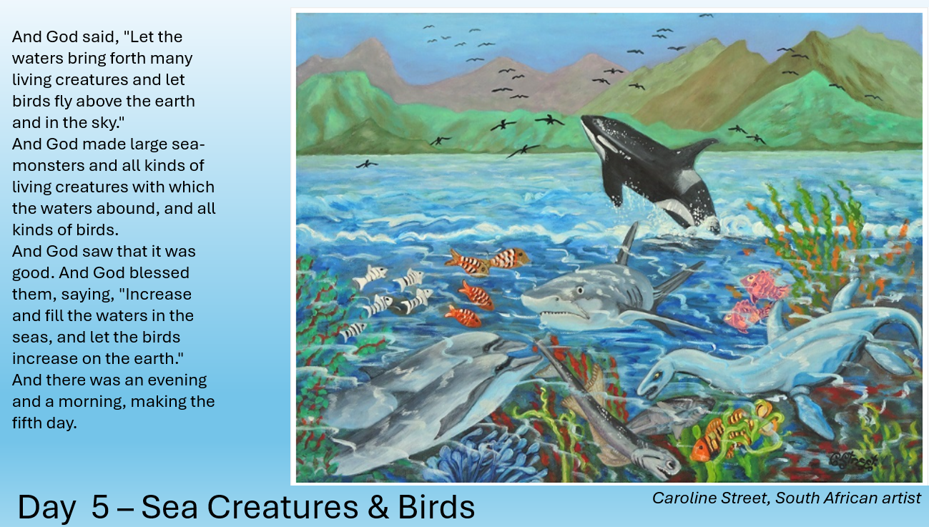

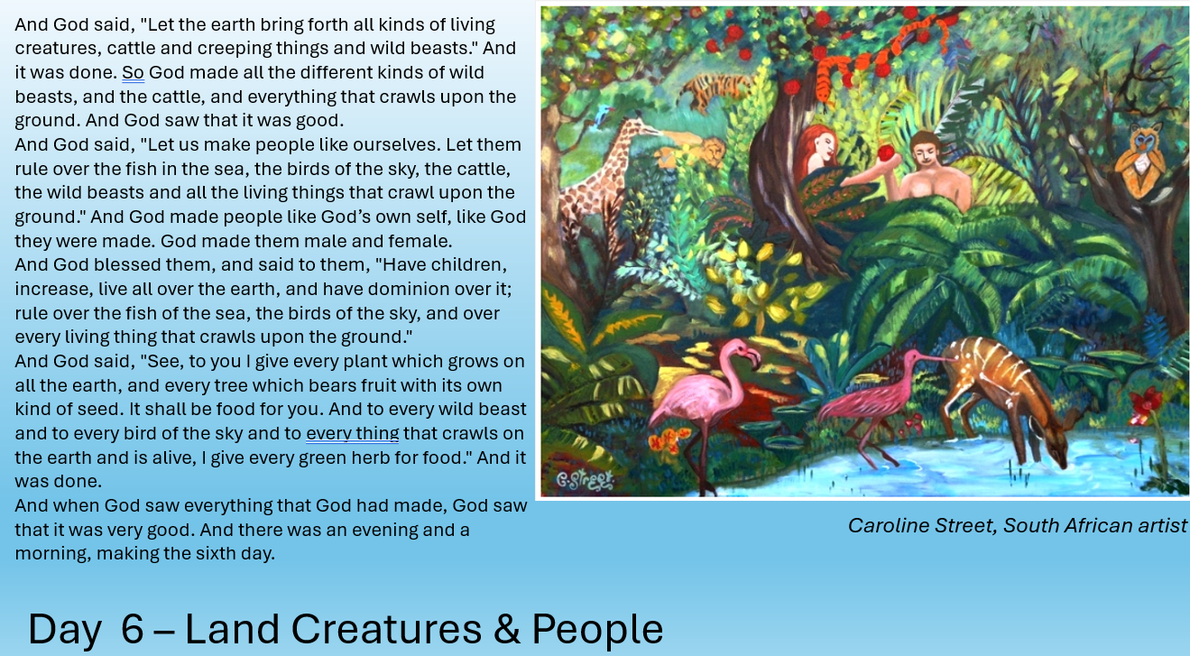

The Stories of God for the People of God.
Thanks be to God.

I still remember when, almost thirty years ago,
our teaching Assistant Eric Elnes walked into
our Hebrew Bible class holding a stack of books under his arm.
He set the books on the table in front of him,
so that we could see the books’ titles:
A cookbook, a science textbook, the Bible, and a “DIY Home Projects” book.
Pointing to the stack of books, Mr. Elnes asked the class,

If you’re looking for an answer to a question about fixing a plumbing issue in your home,
do you crack open the cookbook? (all of us shook our head, no.)
What about if you’re looking for a recipe, do you turn to the science textbook? (again…no…)
If you’re wanting to learn more about the meaning of life, how to treat your neighbor,
find inspiration for personal (and social) transformation, do you open
your “DIY Home Projects” book? (again, our heads shook)
Then lastly, most relevant to our Hebrew Bible class, Eric asked us,
If you are looking for scientific answers to questions about geology, astronomy, and biology,
do you go to the Bible? (Well, no…)
“Some people get confused about what the Bible is seeking to explain,” Mr. Elnes continued,
before going on to make the point that the Bible is a CERTAIN kind of book,
written to inspire, to give insights into the nature of God,
to support the process of spiritual transformation…
But NOT a book intended to explain evolutionary, astronomical,
biological or geological processes, which sometimes
people THINK the Bible is trying to explain as they read Genesis chapter one literally.

The Bible is a book of truth, often more metaphorical than literal,
including, of course, this brilliant recounting of “how the world began.”

I love to think of a creative, imaginative process in which, millennia ago,
elders and ANY who might want to learn gathered at night around a fire,
peering up into the vastness of the sky.

“How did this great mystery all begin?” a curious someone asked.

And an answer emerged, in story form,
In the beginning, there was nothing formed…
and yet God’s Spirit hovered over the void,
and the first words were spoken. God said, “let there be light,”
and there WAS light, And God saw that the light was good.
Then God separated the light from the darkness.
And God called the light Day and the darkness Night.
And there was an evening and a morning, making the first day.

“And then?” another someone asked.

Then God said,
"Let there be a sky and let it divide the waters that are below
from the waters that are above the sky."
And it was done.
And God called the sky the Heavens.
And there was an evening and a morning, making the second day.”

And so on, the story went amongst those sitting around
that thousands-of-years-ago-fire…
with Day three’s (good) land, plants, and trees
with Day four’s (good) sun, moon and stars,
with Day five’s (good) sea creatures and birds of the air
and Day six’s (good) land animals, and (very good) humans
made in God’s own image.
“That is how it all began,” I imagine those elders telling “the gathered”
as, before them, the fire’s embers flickered,
and above them, the twinkling stars declared mystery and wonder.

How else DO YOU point to mystery, get at truth…but by recounting a story?
A six-day story that has none other than God as Source.
A story that seeks, repeatedly, to remind us that God
(Spirit, Energy, Life, Love, call it what you will) has brought what IS into being…
and has been woven into the fabric of all that is since the very beginning.
A mystery hidden in every nook and cranny of all that is life.
A mystery that echoes from chapter one of Genesis to chapter one of John’s gospel,
which begins:
In the beginning was the WORD,
and the Word was WITH God,
and the Word WAS God.
He was in the beginning with God.
All things came into being through him,
and without him not one thing came into being.
What has come into being in him was life,
and the life was the light of all people.
The light shines in the darkness,
and the darkness did not overcome it.

John’s aligning the Jesus mystery with the mystery of the universe…
Faithfulness in mystery, throughout time…

Can the creation story be a little…gift…for us as we begin this chapter of “Ordinary Time.”
[Can the creation story be a little…gift…for us as we begin, here at Summit,
a new series of sermons: Faithful in the Ordinary…(which will stretch
to the middle of July).]
Can we let the creation story inspire our ORDINARY discipleship?
This story as a beginning re-minder of what’s important?
Of the sacred origin of things and beings that are all good, beautiful and sacred, NOT creation as commodity to be bought and sold.

Can the ongoing gift of this creation story be…
a re-set, that helps us to re-frame the narrative that’s leading to so much
climate grief, immigration anxiety, and political exhaustion that we are all experiencing.
For though the story speaks of humans in God’s image as having “dominion” over plants, animals, and creation, the “dominion” takes the form of generous and careful careTAKERS,
stewarding the mystery that IS this created order.

Can the insights from the creation story support our orientation to neighbor
as “holy & good other?” Some neighbors more the same, some more different
and yet, because of the uniqueness of each,
(to borrow the language from our story):
each is so…very…good!

I wonder, what IF our first orientation toward everything in creation were like God’s?
God saw EVERYTHING and deemed it …good!?
What if our orientation…
Toward the light…and the darkness were always “Good.”
Toward the waters and sky, when smooth and when turbulent. What if we could say, Good!”?
Toward earth, its land and plants – the ones that readily bring joy in this season – cherries, foxgloves, azaleas… as well as the invasive to Vermont chervil and poison ivy. What if we could say, “Good!” to it all?
What if our orientation toward all things aquatic –
the Orca and the octopus as well as the marine algae and river rock snot
and other things on our nuisance list…
what if our orientation toward all things flying – my current favorite Swainson’s Thrush and the often-berated mosquito. What if we could say, about them all, “Good!”?
The same for all creatures living on land, the animals praised and the pesty ones,
can we see them all…as good,
including people…those we love to love,
and those we love to hate,
could we see them all, as God does…as very…good?
The Good Creation, mundane and the mystery all rolled into one.

(As we all know,) recently the astronauts aboard the Artemis 2 journeyed
to the far side of the moon…
during a “too familiar time” here on planet Earth where it seems like
we are doing our best to make enemies, not friends,
driven by stealing and storing, not stewarding and sharing.
where our inclination is more toward making war than peace.

A reporter said to the four gravity-defying astronauts,
“As you know there’s so much division at home right now,
what message do you want to send to the American people
about what you’re seeing out that window?”
Astronaut Victor Glover grabbed the floating microphone and said,
“Trust us, you look amazing, you look beautiful. (a little echo of God’s assessment of each day of creation?)” Glover continues, “And from up here you also look like one thing. Homo sapiens is all us, no matter where you are from or what you look like…you are all one people.
[Our mission] has brought us together and showed us what we can do when [we don’t] just put our differences aside, [but] when we bring our differences together and use the strengths…[we can] accomplish something great.

Which just might be our invitation, through this Creation story,
as we enter ORDINARY Time,
where and when we live our ORDINARY lives,
here and now.

For each ORDINARY moment IS an opportunity…
to live in Way of Love,
to see goodness in whatever lies before us,
to recognize God in and through every created thing…
and to be faithful amidst all that is magnificent and messy
in this mystery called life.

I’ll close with this poem by Kim Stafford, Nest Filled
Use your whirling wings to find the right tree.
Use your pert eye to choose the level limb.
Use your nimble feet to cherish the hospitable fork.
Use your fearless beak to gather twigs, leaves,
grass and thistledown to weave your basket-house
open to the wuthering sky.
Use your body to be the tent over tender pebbles,
lopsided moons. Then wait — warm, alert, still
through wind and rain, hawk-shadow, owl night.
Use your life to make life, spending all you have
on what comes after. And if you are human, a true
citizen, fully awake, then learn from the sparrow
how to build a house, a village, a nation. Use instinct
to find the right place. Use thought to know the right time.
Use wisdom to design the right action.
In the era of stormy weather, build your
sturdy nest, and fill it with the future. (repeat last line?)
May all of God’s people say, Amen.

