SCRIPTURE READING [CHVO] Exodus 32:1-14

This morning, we continue our stories of Moses and the Israelites in the wilderness.
In today’s story, Moses is on the Mountain of God,
having received the Ten Commandments, but not having descended from the mountain yet.

Hear now the story from Eugene Peterson’s translation, The Message, Exodus chapter 32:

32 When the people realized that Moses was taking forever
in coming down off the mountain, they rallied around Aaron and said,
“Do something. Make gods for us who will lead us.
That Moses, the man who got us out of Egypt
—who knows what’s happened to him?”
²⁻⁴ So Aaron told them, “Take off the gold rings from
the ears of your wives and sons and daughters and bring them to me.”
They all did it; they removed the gold rings from their ears and brought them to Aaron.
He took the gold from their hands and cast it in the form of a calf,
shaping it with an engraving tool.
The people responded with enthusiasm: “These are your gods, O Israel,
who brought you up from Egypt!”
⁵ Aaron, taking in the situation, built an altar before the calf.
Aaron then announced, “Tomorrow is a feast day to God!”
⁶ Early the next morning, the people got up
and offered Whole-Burnt-Offerings and brought Peace-Offerings.
The people sat down to eat and drink and then began to party.
It turned into a wild party!

⁷⁻⁸ God spoke to Moses, “Go! Get down there!
Your people whom YOU brought up from the land of Egypt have fallen to pieces. In no time at all they’ve turned away from the way I commanded them:
They made a molten calf and worshiped it. They’ve sacrificed to it and said,
‘These are the gods, O Israel, that brought you up from the land of Egypt!’”
⁹⁻¹⁰ God said to Moses, “I look at this people—oh! what a stubborn, hard-headed people!
Let me alone now, give my anger free reign to burst into flames and incinerate them.
But I’ll make a great nation out of you.”
¹¹⁻¹³ Moses tried to calm his God down. He said,
“Why, God, would you lose your temper with your people?
Why, you brought them out of Egypt in a tremendous demonstration
of power and strength.
Why let the Egyptians say, ‘God had it in for them—
brought them out so God could kill them in the mountains,
wipe them right off the face of the Earth.’
Stop your anger. Think twice about bringing evil against your people!
Think of Abraham, Isaac, and Israel,
your servants to whom you gave your word, telling them
‘I will give you many children, as many as the stars in the sky,
and I’ll give this land to your children as their land forever.’”
¹⁴ And God did think twice,
deciding not to do the evil God had threatened against God’s people.

CONTEMPORARY READING

The Road Not Taken

By Robert Frost
Two roads diverged in a yellow wood,
And sorry I could not travel both
And be one traveler, long I stood
And looked down one as far as I could
To where it bent in the undergrowth;

Then took the other, as just as fair,
And having perhaps the better claim,
Because it was grassy and wanted wear;
Though as for that the passing there
Had worn them really about the same,

And both that morning equally lay
In leaves no step had trodden black.
Oh, I kept the first for another day!
Yet knowing how way leads on to way,
I doubted if I should ever come back.

I shall be telling this with a sigh
Somewhere ages and ages hence:
Two roads diverged in a wood, and I—
I took the one less traveled by,
And that has made all the difference.

PROMPTING

Dr. Trent Foley was a religion professor of mine in college, not one of my favorites honestly,
mostly on me… you will soon understand why.
The course was Religious Types in Christianity and
Professor Foley assigned a 1,500 word paper on apostasy due next class.
“I’ve got this,” I thought to myself, making my way to the library that evening and diving right in.
I’d been thinking a lot about faith…
and how those early apostles shaped and modeled spiritual practices and right action.
What really DID apostleship mean…to BE an apostle…I could write for a while on that,
…and I did.
In fact, when I turned it in I thought, “solid paper on that subject.”
So, I was absolutely mortified when Professor Foley returned my paper
with a big RED “F” next to my cover page title, “Perspectives on Apostasy.”
A double-lined red circle around the word “apostasy,”
with no corrections anywhere in the paper except the ALL CAPS note by the red circles,
DO YOU HAVE A DICTIONARY? I felt the temperature in the room go up.
It was an epiphany, NOT the kind I ever wanted to have,
if I couldn’t turn back the clock and re-write the paper, then wishing that
there were some way to not have to talk to Professor Trent Foley ever again!
Even now, I am humiliated and mortified as I recount the thirty-six-year-old story.
WHAT was I thinking? Short answer, “I wasn’t, or at least not enough.”
And, when I’m not thinking, I will quickly take a shortcut,
think… “Oh, I know!,” and move way too quickly for anyone’s good.
(Which, just for the record, I continue to struggle with all these years later –
though I have NEVER since written a paper
without first going to the dictionary to define the term/subject.)
“Is it too late to get any points for that?” he asks hopefully!
Apostasy, as I suspect YOU know, is defined:
1 : an act of refusing to continue to follow, obey, or recognize a religious faith
2: abandonment of a previous loyalty. Synonym for apostasy? Defection.

Not only is “apostasy” not synonymous with “apostleship”
but the CRUEL truth is that it’s almost the EXACT opposite!
Poor nineteen-year-old Carl! (Not that I expect, nor deserve ANY sympathy.)

Apostasy (rightly defined) is a fair way to describe
the Israelites and Aaron’s actions in today’s story, for their impatience
led them to go against the very precepts which had just been given to Moses
in the Ten Commandments which we explored last week in Exodus, chapter 20.
Since then some happened, on the Holy Mountain…
recounted in Exodus chapters 21 through today’s chapter 32:
Things like God giving Moses social and religious laws,
specifications for the ark of the covenant and priestly vestments,
as well as the practice of priestly ordination,
which did keep Moses upon the mountain for a long time.

Impatience and worry had the Israelites riding the struggle bus,
replete with the “when are we going to get there? When are you going to come home?”
energy of young kids waiting for SOME arrival!

One of the things I love about THIS story,
perhaps because of my own fallibility evidenced by my apostasy story,
is the “O my God, really?” nature of the story.
It’s such a riot that the “have no other gods before me” and
“no graven images” commands had not long ago been given to the Moses when
the people basically did JUST what they were clearly instructed NOT to do.
(Welcome to the human condition!)
My different parts have varied feelings about the forgers of the golden calf.
My compassionate part GETS it…
and can cut the impatient Israelites some slack because Moses WAS very delayed
coming down the mountain (remember he was up there
for a “forty days and nights”-long-time).
I would have wondered, and I would have gotten impatient, too.
And, the legalist part of me, would build the case that
the Israelites hadn’t YET ACTUALLY received the commandments that specifically prohibit graven images and the creation of a calf-like golden god! Moses HAD RECEIVED the
Ten Commandments but HAD NOT made his way down the mountain, yet,
to give them to the people. See, it’s not really THAT bad!

That said, scholars of these texts urge readers to not attach too much significance
to the chronology of events, because in this part of Exodus,
events might OR MIGHT NOT have been recorded chronologically.
For example, scholars say, don’t place too much weight on whether
Aaron and the Israelites had received the instructions in the Ten Commandments
before they broke them by fashioning the golden calf. Okay…

Rabbis reflecting on this golden calf text remind us,
“The [Golden Calf] incident left deep scars on the memory of Israel.
Nothing would be quite the same thereafter and a midrash says that all ills
which have befallen the people since that time…
are in part traceable to the sin of the gold calf.”
…seminal incident that the calf forging was…

A commentary on the Torah notes,
“Two questions have been raised about the golden calf:
First, how could the people revert so quickly to idolatry?
And, second, did they in fact consider the calf as a substitute for God?
A closer look reveals that idolatry, in the strict sense, was not involved.
The people were leaderless since Moses had left them, and his prolonged absence created great anxiety amongst them. He had been their visible contact with the invisible /God,
and it was such a contact they craved as reassurance that they were not forsaken.
[Bulls were thought of as divine pedestals, and it was such a pedestal – later legitimized by the cherubim on the ark – that the people constructed.]
Any idea that the Israelites really believed that the gold from their earrings
could fashion a god at will rests on a misunderstanding of ancient beliefs,
The bull (the calf) was the new link with God and was meant to replace
‘that man Moses’ who, so to speak, had been God’s footstool.

The golden calves are “the things we trust to deliver us from the wilderness of uncertainty.” (end of quote)

The Golden Calf is, essentially, a product of anxiety.
The Israelites are nervous, anxious.
Worried, maybe, about their leader Moses’ wellbeing up on that mountain with God. Worried, that they might be left all alone, abandoned, forsaken, comfortless.
Worried… about the passing of time…”What about us?” they wondered.
Anxious, and increasingly frustrated, that things aren’t moving along…
the fulfillment of things, places, experiences promised to them.
I get their worry…share some of it myself. You?

For wilderness IS terrain ripe for anxiety – so much is uncertain.
For them, there have been the worries
…of where our next meal will come from?
(God’s solution(s): manna, white on the ground,
which the Israelites also get impatient about…
and water from stone, is provided.)
Worries…
…of “How will we know where to go, in the wilderness, how will we be guided?”
(And God’s solution: pillar of cloud by day and fire by night as guides)…
worries…
…of who will protect and care for us, especially when Papa Moses is away?
(God is there, still…remember, the wilderness experience
ALL started with God demonstrating
liberating and protecting power with the escape from Egypt’s slavery).
But…still…there are the worries…
Such is the fertile ground for anxiety which the wilderness provides.

God will and DOES provide, they/we are reminded over and over again…
In the bigger picture, there is enough, there is provision, there is…love.

And the reality of the every day, the truth of being human…is that it’s hard to wait, trust,
zoom out and see the bigger picture when the everyday smaller pictures are so stressful,
it IS hard wait and trust…
that justice WILL prevail when the unjust so regularly force or get their way,
It can be hard to believe that the greatest of these IS…love…when there’s
so much hatred and animosity everywhere we turn.
It’s no wonder, is it, that we live beset by anxiety…
which drives us to do all sorts of things in our attempt to manage worry.

And, if it’s rough going for those of us who
have more of our life on earth behind us than before us,
what ABOUT the young generation, The Anxious Generation, as Jonathan Haidt
calls the dilemma facing our young people.
Two years ago, Haidt wrote a book titled,
“The Anxious Generation: How the Great Rewiring of Childhood
Is Causing an Epidemic of Mental Illness.”
Maybe you’ve heard of it – it’s a book that explores the impact of social media on children – tracking the changes in mood disorders like anxiety and depression
across the years of the proliferation of social media in our lives,
offering statistics like these:

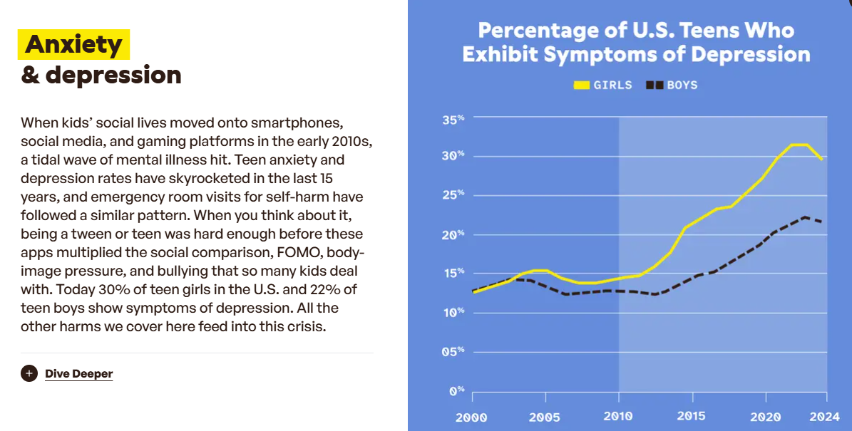

What do we do with anxiety, then and now?
Instead of building a golden calf
(or worshipping at the altar of “a golden calf” [hold up smartphone]),
there ARE things that we do.
Children and those who care for them…
wanting a less anxious generation created a movement,
It’s called the TAG Movement – The Anxious Generation Movement.

Among many other things, the TAG movement is working
to cultivate and implement what they call the Four New Norms.
Let me tell you a bit about it…

The Four New Norms…
Delay smartphones until high school
This doesn’t mean no communication. Living in the post-payphone age, it can feel unrealistic to send kids out into the world without a way to call home or coordinate with friends. But a basic device can do everything they actually need, without introducing the potential distraction and harms of attention-maxxing apps. Check out this guide to basic phones by Jean Twenge or explore more resources on Wait Until 8th.

No social media until 16
These platforms aren’t designed with kids’ wellbeing in mind, and no parental control setting fixes that. Even so, that can be hard for the one kid who isn’t on Snapchat or Instagram. Try getting on the same page with your kids by talking about how social media can take time away from real-world experiences and friendships, and comes with real risks (The Amazing Generation book is a great resource for kids and teens). Like with delaying smartphones, you can also make it easier for your kids by banding together with other families.

Phone-free schools, bell to bell
While this norm isn’t technically in the hands of individuals, we still have ways of impacting it. Parents and teachers have been instrumental in advocating for phone-free school policies across the country. See how your state is doing on this issue in our Childhood Index, and ask your school about their approach. For kids, you can remind them that this gives them more time to goof off during lunchtime.

More independence, free play, and responsibility in the real world
The flip side of limiting online time is replacing it with more freedom, adventures, and connection in the real world. Kids are inheriting a complicated world, but the skills and confidence they need are built in small, everyday ways: a solo trip to the grocery store, an unsupervised playground outing with their friends, or making dinner on their own (with the requisite stove safety lecture, of course). Consider this a sign to say yes to things that might make them gleeful and you a little uncomfortable. Schools can back this up too, with things like the Let Grow Experience.

Maybe it wouldn’t come as a surprise - these norms (all of them, I would say?)
involve patience, restraint, limits on impulse and desire –
All things that the Israelites could have benefited from in their working with
their own anxiety…
anxiety that led THEM to build the Golden Calf.

Perhaps working with anxiety is essentially about slowing down…
Instead of immediately or instinctually turning to some release from it:
(forging a golden calf, picking up a cell phone,
reading one more article or listening to one more news story)…
perhaps we find a pause button and press it…
let the situation, the anxiety…just be for a few…
for as I’ve heard said, “Anxiety allowed…is not longer anxiety.”
Sitting with what is, seeing it – anxiety or any of its cousins - as teachers,
and making space for welcoming,
not moving too quickly to solving.
Like the practice I heard of from Tara Brach, R.A.I.N.
when one is feeling distress, anxiety included.
R - recognize what’s going on inside yourself.
A- allow whatever it is to just be, no need to run from it, change or solve it.
- investigate what’s going on with a stance of…curiosity, and
N – nurture oneself with a little self-compassion.

Slowing things down, letting anxiety (or whatever emotion) just be…
are some (faithful) ways to give ourselves space, room to consider our options,
Do we need to succumb to the release valve of building a calf,
or whatever (science would now tell us dopamine hit) we THINK we can’t live without?

For as we slow down, we recognize that we do have choices…God help us!
Two roads often do diverge in a wood…
and ours IS the choice, “Which will I travel by?”
Which is mine to take, on any given day, at any given chapter of my life?
We sit with the questions, live them, even…
Will I be driven by my limiting anxiety…or by some more expansive and encompassing trust?
Will I be driven by frustration or fear, or by an abiding faith…that there is always…more possible?

And as we sit with and live the questions…we are in the best of company,
for according to today’s story anyway,
God is one of us…God had an emotional reaction…
got SO ANGRY at the wayward chosen…
that God got a bit reactive…ready to wipe the slate clean and start over,
until Moses talked God off the ledge…made a little space for God(?)
to process those emotions, mind you…
to consider which road even God might take as two diverged
in the wood that God had made…
bringing God back to God’s own senses, we might say,
to the sense of love and grace, forgiveness and peace…
often the path less travelled by, but which DOES make all the difference. Amen.

Plaut. The Torah: A Modern Commentary, p. 645.
ibid.
Modern Interpretations of the Golden Calf

